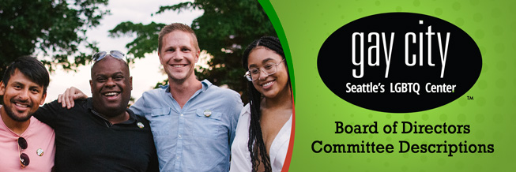

All board members will serve on one of the three committees listed below. Committee meetings are held during designated committee meeting times or at a co-chair’s discretion. During a term, members may serve on the same or different committees, as space and distribution permit. Each committee will work to incorporate the infrastructure, programmatic, and sustainability strategic goals in their work.

Development Committee (board contributions and events)
- Works in conjunction with the Development Director on major events involving donors and community connections
- Plans and promotes Eden Garden Party, Give Out, GiveBig, and Stronger Together: World AIDS Day Breakfast, as well as the development of new events and outreach to major donors
- Collaborates with Development Director to create and manage board member pledge plan, and manage the completed board member pledge plan

Connections Committee (community stewardship)
- Cultivates and sustains the professional connections among networks (e.g., GSBA events and reps) and organizations
- Seeks out opportunities for board and staff interactions to strengthen whole organization connections
- Manages outreach to diverse LGBTQ+ communities to increase relationship and understanding of Gay City through board networks (e.g. create network maps that tie in strategic relationships)
- Prepare a mission moment for each board meeting (e.g. client story)

Mission and Governance Committee
- Manages recruitment and orientation of new board members
- Tracks board member terms
- Continual review of board functions, by-laws, and annual executive director evaluation
- Plans the annual board retreat and any ad hoc board retreats through the year

Finance Committee
- Review financial statements and reports at a minimum of each month
- Report to the board monthly on the financial health
- Draft annual budget and adjust as needed for the board’s approval

